**Expt. No. 9**

**BJT Characteristics and Analysis**

**A. BJT output characteristics (Using IV analysis instrument):**

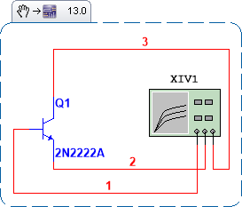

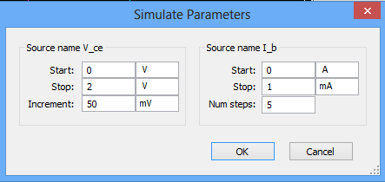

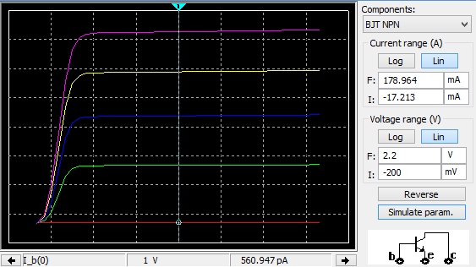

**B. BJT input and output characteristics (Using DC Sweep):**

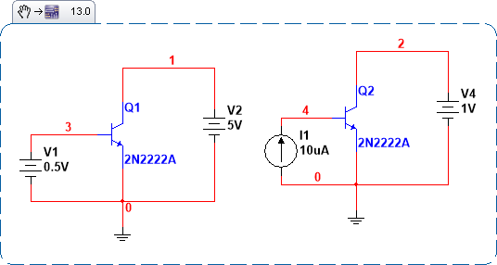

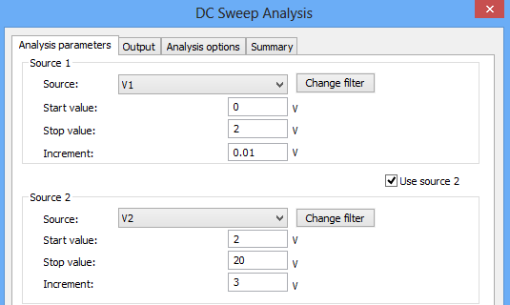

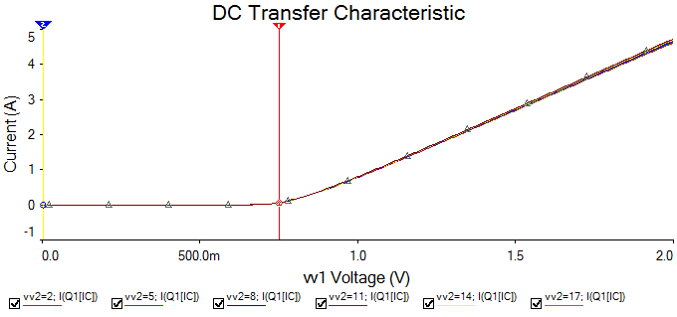





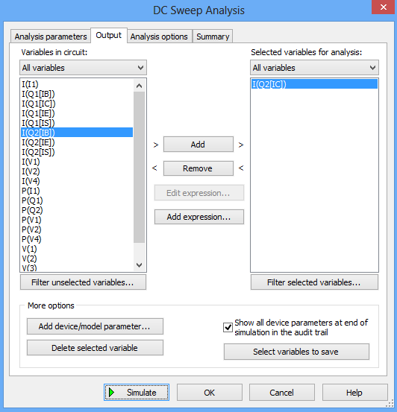 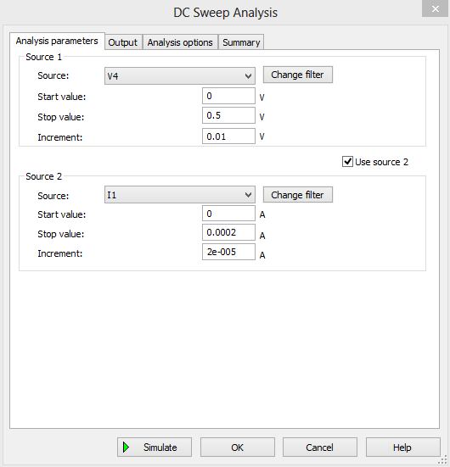

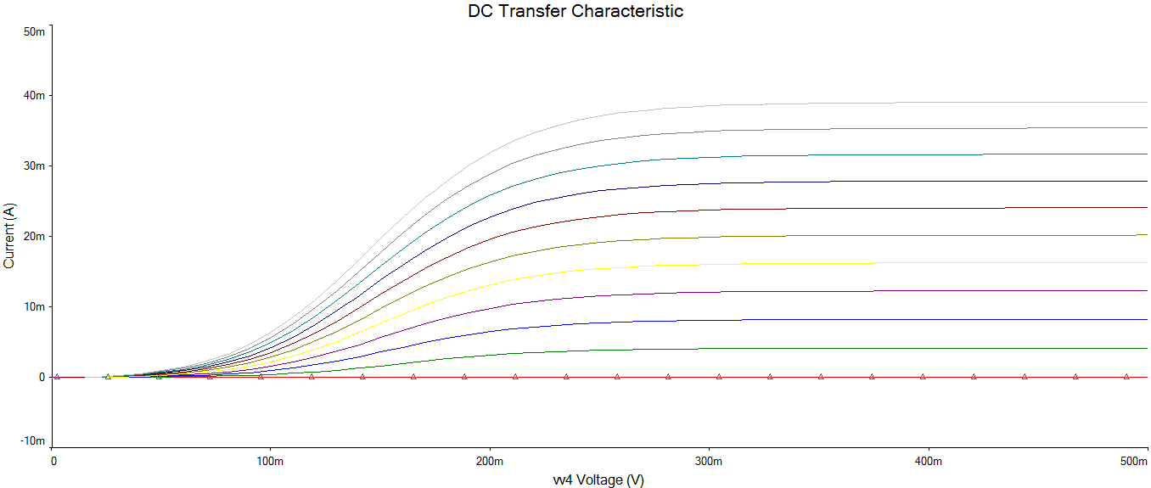

**C. DC Operating Point Analysis**

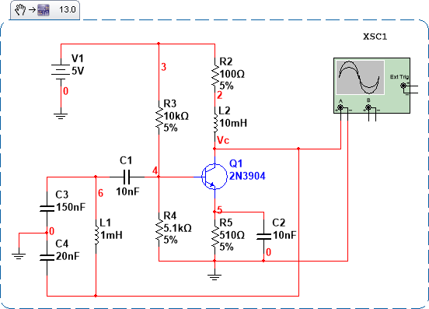

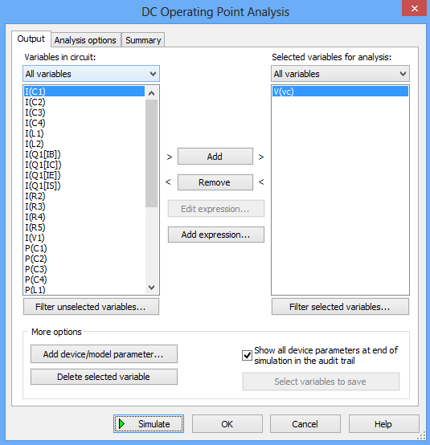

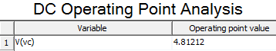

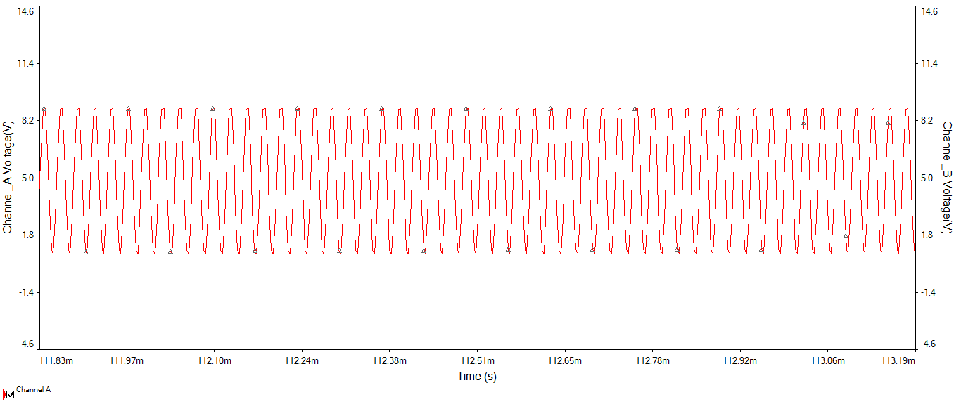

**D. AC Operating Point Analysis**

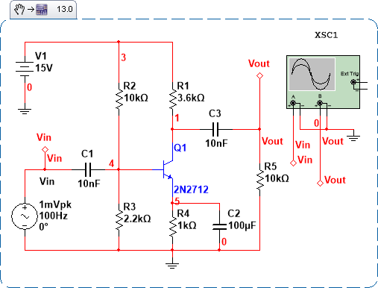

**ICQ vs Freq**

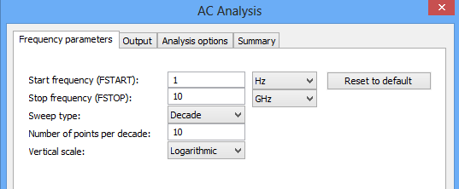

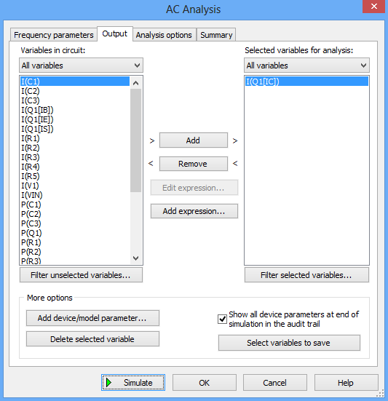

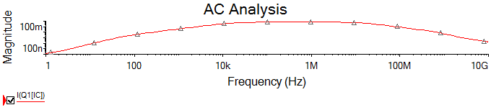

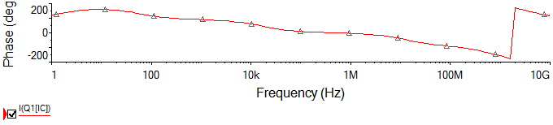

**Vout vs Freq**

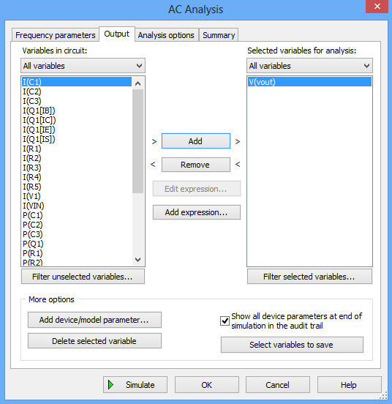

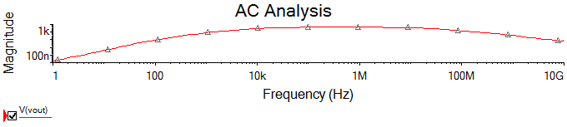

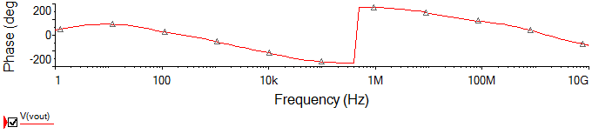

1. Verify the DC operating point analysis carried for Colpitts oscillator (Calculate the value of collector Voltage Vc).

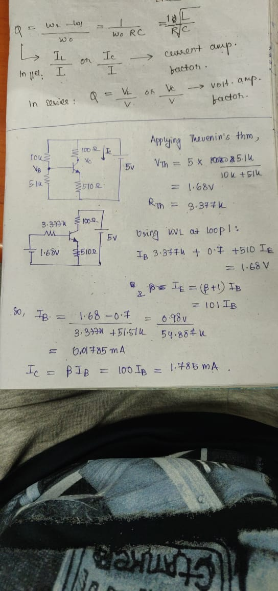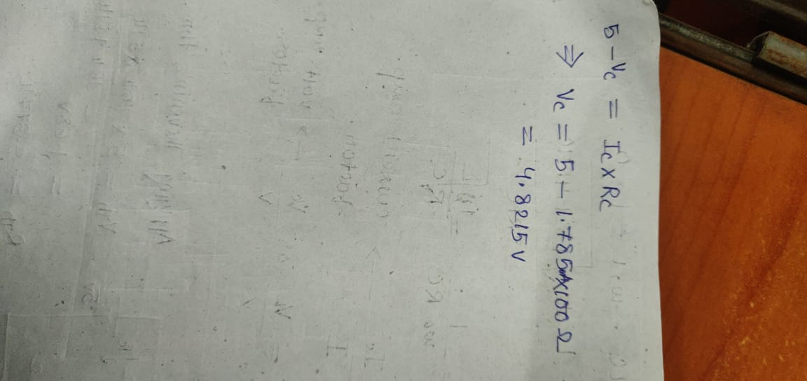

1. Calculate % change in β value between any two output characteristics.

|  |  |  |  |  |
| --- | --- | --- | --- | --- |
| **Ic** | **Ib** | **β** | **% change** | **Vce** |
| 0.161 | 0.001 | 161 | 15.21 | 1 V |
| 0.273 | 0.002 | 136.5 |

1. Calculate the bandwidth of the CE amplifier. Discuss the effect of all three capacitors on the frequency response of the amplifier.

A: Bandwidth of the CE amplifiers is defined as the frequency range for which the output signal has a constant magnitude with all other parameters kept constant.

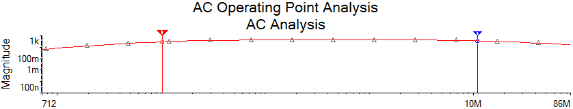

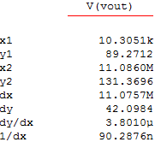

Thus from the frequency response curve obtained from the above simulations, the bandwidth of CE amplifier can be calculated as

BW= 11.086 MHz – 10.3051 KHz = 11075.7 KHz

There are basically two types of capacitors connected in the CE amplifiers;

i) Coupling capacitors

ii) Bypass capacitors

* 1. A **coupling capacitor** is a capacitor which is used to couple or link together only the AC signal from one circuit element to another. The capacitor blocks the DC signal from entering the second element and, thus, only passes the AC signal.
  2. A **bypass capacitor** is a **capacitor** that shorts AC signals to ground, so that any AC noise that may be present on a DC signal is removed, producing a much cleaner and pure DC signal.